[Setting Up for Twilio Flex Plugin Development - YouTube](https://www.youtube.com/watch?v=etA3UFKHGhw)

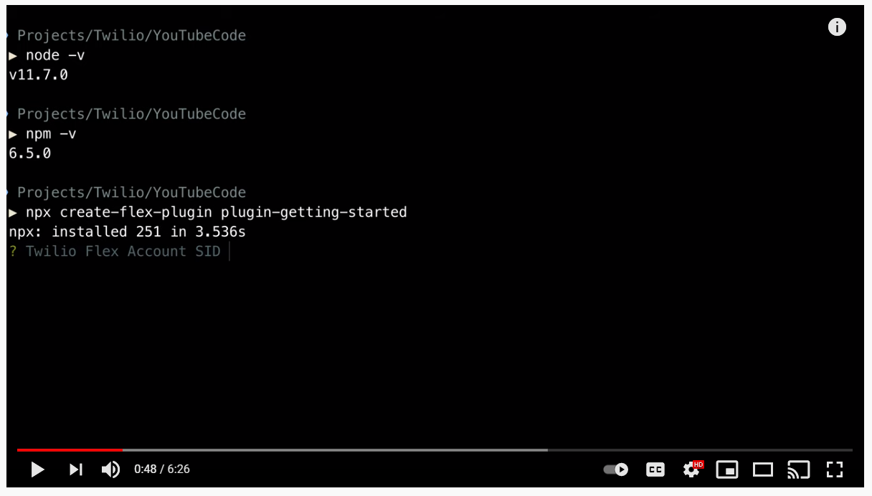

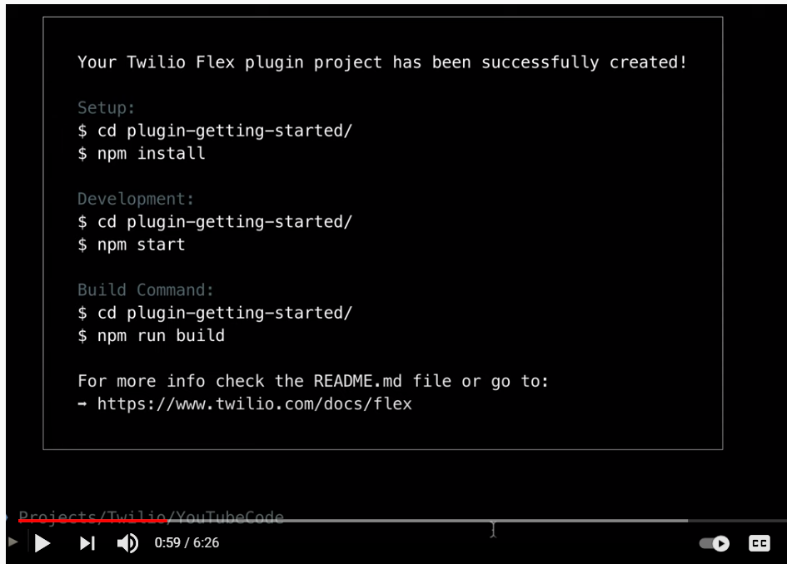

Could you run the following command in the CLI and let me know if you see the Flex plugin listed and what version shows:

twilio plugins

If you don't see @twilio-labs/plugin-flex listed after running that then it would need to be installed with the following command:

twilio plugins:install @twilio-labs/plugin-flex@beta

The NPM and Node versions you are using should be fine based on our requirements:

1. NPM version 5.0.0 or 6 (type npm -v in your terminal to check) ( **Note:**We are currently working on resolving an issue related to npm version 7 and above)
2. Node version 10.12.0 or later (type node -v in your terminal to check)

PS D:\Twilio\Flex\Learning\plugin-getting-started> twilio flex:plugins:deploy --major --changelog "Initial Deployment Rajneesh" --description "Testing plugin Rajneesh"

The plugin plugin-getting-started version (v3) is not compatible with this CLI command.

Run $ twilio flex:plugins:upgrade-plugin --beta --install to upgrade your plugin.

///////////////////

PS D:\Twilio\Flex\Learning\plugin-getting-started> twilio flex:plugins:upgrade-plugin --beta --install

Using profile FlexDev (AC2ded79841f9fbf7c421a32aa16b18d9b)

┌────────────────────────────────────────────────────────────────────────────────────────────┐

│ │

│ ‼ You are about to upgrade your plugin to use the latest version of Flex Plugin CLI. ‼ │

│ │

└────────────────────────────────────────────────────────────────────────────────────────────┘

? Please backup your plugin either locally or on GitHub. Do you want to continue? (y/n) y

Upgrading your plugin from v3 to v4

√ Cleaning up the scaffold

√ Updating package dependencies

√ Removing package scripts

√ Cleaning up node_modules and lock files

| Installing dependencies using npmLove JSS? You can now support us on open collective:

> https://opencollective.com/jss/donate

/ Installing dependencies using npmadded 1952 packages from 1042 contributors in 297.293s

√ Installing dependencies using npm

�🎉 Your plugin was successfully migrated to use the latest (v4) version of Flex Plugins CLI.

Next Steps:

**Run $ twilio flex:plugins --help to find out more about the new CLI.**

PS D:\Twilio\Flex\Learning\plugin-getting-started>

////////////////////////////////////////////////

PS D:\Twilio\Flex\Learning\plugin-getting-started> twilio flex:plugins:deploy --major --changelog "Initial Deployment Rajneesh" --description "Testing plugin Rajneesh"

Using profile FlexDev (AC2ded79841f9fbf7c421a32aa16b18d9b)

√ Validating deployment of plugin plugin-getting-started

√ Compiling a production build of plugin-getting-started

√ Uploading plugin-getting-started

√ Registering plugin plugin-getting-started with Plugins API

√ Registering version v1.0.0 with Plugins API

�🎉 Plugin (private) plugin-getting-started@1.0.0 was successfully deployed using Plugins API

**Next Steps:**

**Run $ twilio flex:plugins:release --plugin plugin-getting-started@1.0.0 --name "Autogenerated Release 1616799708062" --description "The description of this Flex Plugin Configuration." to enable this plugin on your Flex application**

PS D:\Twilio\Flex\Learning\plugin-getting-started>

**The plug-in we created using the video is the old plugin V3.**

**To create the new plug-in V4 go to the line below and follow the steps.**

[**https://www.twilio.com/docs/flex/quickstart/getting-started-plugin**](https://www.twilio.com/docs/flex/quickstart/getting-started-plugin)

**If the network is slow then increase the yarn timeout:**

**yarn config set network-timeout 120000 -g**

**Then try and install** twilio plugins:install @twilio-labs/plugin-flex@beta

Debugging a Flex Plugin with VS Code

[Debugging a Flex Plugin with VS Code - Twilio](https://www.twilio.com/docs/flex/developer/plugins/debugging-with-vscode)

The twilio flex:plugins:start command enables you to load multiple plugins on a local instance of Flex. It can load plugins either from the local source directory of a plugin or those that are currently enabled on your Flex application. This command makes it easier and quicker to test a plugin your developing locally with other plugins.

https://www.twilio.com/docs/flex/developer/plugins/cli/run-multiple-plugins

**Plugin fix**

As I mentioned during our meeting today, some customers were seeing errors when deploying flex plugins. The error you would see is:

Error: Request post to Builds failed with status 400 and message unsupported runtime: node10

To fix this, follow the below instructions. The instructions are different depending on if you are using the older plugin builder or the newer version:

### **For v3**

- If using the Plugins CLI, run “*twilio plugins:install @twilio-labs/plugin-flex”*

- Also update package.json and bump create-flex-plugin and flex-plugin-scripts to version 3.14.6

- Run npm install then run npm run deploy again

### **For v4**

**- Upgrade the CLI: ”*twilio plugins:install @twilio-labs/plugin-flex@beta*”**

**- Run *twilio plugins:upgrade-plugin --install --yes --beta***

**- Run *twilio flex:plugins:deploy --changelog "new changelog"***